**1.INTRODUCTION**

**1.1.ABSTRACTION**

An online furniture shop that allows users to check for various furniture available at the online store and Booking online. The project consists of list of furniture products displayed in various models and designs. The user may browse through these products as per categories. If the user likes a product they may add it . Once user wishes to checkout they must register on the site first. they can then login using same id password next time. Here they use Html,Css,javascript to make the entire frontend. The middle tier or code behind model is designed in PHP And Myaql serves as a backend to store furniture lists and inventory data Thus the online furniture Booking project brings an entire furniture shop online and makes it easy for both customer and seller to make furniture deals.

**1.2.PROJECT DESCRIPTION**

**1.2.1.MODULE DESCRIPTION**

The main purpose of this module is provide all the functionality realted to customers. It tracks all the information and details of the customer. We have developed all type of CRUD (Create, Read, Update and Delete) operations of the customers. This is a role based module where admin can perform each and every operations on data but the customer will be able to view only his/her data, so access level restrictions has also been implemented on the project.

**1.2.1.MODULE DESCRIPTION**

* Admin
* User

**Admin Module**

* Admin is the superuser of the website who can manage everything on the website. Admin can log in through the login page
* **Dashboard**: In this section, admin can see all detail in brief like the total new order, total confirmed order, total delivered order, total canceled order, Total Order, Total Product Products, Total Brand and Total Registered Users
* **Brand**: In this section, admin can manage furniture Brands (add/update).
* **Category**: In this section, admin can manage the furniture Category (add/update).
* **Sub-Category**: In this section, admin can manage furniture Sub-Category (add/update).
* **Products**. In this section, admin can manage furniture Products (add/update).
* **Orders**: In this section admin can view the order details and they have also the right to change order status according to current status.
* **Pages**: In this section, the admin can manage about us and contact us pages.
* **Reports**: In this section admin can view order details, order counts, and sales report according to dates.
* **Reg Users**: In this section, admin can view register users.
* **Search**: In this section, admin can search a particular order with the help of the order number.
* Admin can also update his profile, change the password, and recover the password.

**User Module (Registered Users)**

* **Sub-Category**: In this section, admin can manage furniture Sub-Category (add/update).
* **Home:** In this section, user can view the home page of the website.
* **Furniture:** In this section, user can view furniture products according to categories and add products to the cart.
* **My Accounts**: In this section user view and update his/her profile, view the products which is added in the cart, view order details, can change his/her own password, and logout from accounts.
* User has also a facility to view his/her invoice and cancel the order if he/she wants to cancel.
* **Brief Information about the homepage**  
  On this page guest user can only view about us page, contact us page, and which product is available if anybody wants to order the product they must register.

**2.SYSTEM ANALYSIS**

**2.1.EXISTING SYSTEM**

In the existing system details are maintained manually. Due to this the data retrieved is time consuming. Due to human calculation errors occur. Even when the data is maintained on spreadsheet inconsistency occurs as an order might be missed or wrongly entered or twice.Data are stride an excel sheet which takeslot of time and data may be corrupted.As storage and exchange of data is achieved only by use of excel sheets which lack validation capabilities, there is always risk of invalid, inaccurate or incomplete data being fed in computer.Difficulty in managing multiple forms.Lack of security.

**2.2.PROPOSED SYSTEM**

The proposed system is computerized and has been developed using advance language therefore it gives more facilities than present system. It provides quick access to any data. In this system user have to enter the data only once and then it get linked with all files. This reduces the workload of user and it is also a time saving process. The information about any Subscriber can be easily retrieved. The system maintains all records easy.The new system will convert manual work to the computerized work.By converting manual work to the computerized work in that case it will remove all paper work.By maintaining all the work on computer will increase our accuracy as well as speed of our work.It will easily used and the time consuming is decreased.

**2.3.FEASIBILITY STUDY**

Feasibility study is the measure of how beneficial or practical the development of an information system will be to an organization. The Feasibility analysis is across life cycle activity and should be continuously performed throughout the system life cycle Feasibility tests.

**2.3.1.OPERATIONAL FEASIBILITY**

The proposed system will simplify almost all operations of the agency.The system is user friendly and it is easily accessible to its users. The system will reduce most of paper work resulting in improvement of quality of work.

**2.3.2.TECHNICAL FEASIBILITY**

Technical feasibility is mostly concerned with whether the system proposed for development can be computerized. It is always desired to select best package that will be easy to implement for system designing and must be flexible as possible with other programmers or outside developers and as possible to user.The system has been developed in and Ms-Access. Available hardware configuration is sufficient for developing software. So, the system is technically feasible.

**2.3.3.SCHEDULE FEASIBILITY**

The duration of time required for the project has been planned appropriately and it is the same as the duration of time expected by the customer. Therefore the product can be delivered to the customer within the expected time duration, satisfying the customer. Hence the project is feasible in scheduling.

**2.3.4.ECONOMIC FEASIBILITY**

The duration of time required for the project has been planned appropriately and it is the same as the duration of time expected by the customer. Therefore the product can be delivered to the customer within the expected time duration, satisfying the customer. Hence the project is feasible in scheduling.

**3.SYSTEM REQUIREMENTS SPECIFICATION**

**3.1 HARDWARE REQUIREMENTS**

Processor : Intel Core i7 Duo Processor

Clock Speed : 1.20 GHz

RAM : 4 GB

**3.2 SOFTWARE REQUIREMENTS**

Operating System : Windows,Linux,Mac

Technology Used : XAMPP

Front-end : PHP

Back-end : MySQL

**3.3.SOFTWARE DESCRIPTION**

**3.3.1 HTML**

HTML or Hyper Text Markup Language is the main markup language for creating web pages and other information that can be displayed in a web browser.HTML is written in the form of HTML elements consisting of tags enclosed in angle, within the web page content.HTML elements form the building blocks of all websites. HTML allows images and objects to be embedded and can be used to create interactive forms. It provides a means to create structured documents by denoting structural semantics for text such as headings, paragraphs, lists, links, quotes and other items. It can embed scripts written in languages such as JavaScript which affect the behavior of HTML web pages. Web browsers can also refer to Cascading Style Sheets (CSS) to define the look and layout of text and other material.

**3.3.2. JAVASCRIPT**

JavaScript (JS) is a dynamic computer programming language. It is most commonly used as part of web browsers, whose implementations allow client-side scripts to interact with the user, control the browser, communicate asynchronously, and alter the document content that is displayed. It is also being used in server-side programming, game development and the creation of desktop and mobile applications.

**3.3.3. PHP**

PHP is a general-purpose scripting language geared toward web development. It was originally created by Danish-Canadian programmer Rasmus Lerdorf in 1993 and released in 1995. The PHP reference implementation is now produced by The PHP Group. PHP was originally an abbreviation of Personal Home Page, but it now stands for the recursive initialism PHP: Hypertext Preprocessor.PHP code is usually processed on a web server by a PHP interpreter implemented as a module, a daemon or as a Common Gateway Interface (CGI) executable. On a web server, the result of the interpreted and executed PHP code – which may be any type of data, such as generated HTML or binary image data – would form the whole or part of an HTTP response. Additionally, PHP can be used for many programming tasks outside the web context, such as standalone

graphical applications and robotic drone control. PHP code can also be directly executed from the command line.

**3.3.4. CSS**

CSS is the language for describing the presentation of Web pages, including colors, layout, and fonts. It allows one to adapt the presentation to different types of devices, such as large screens, small screens, or printers. CSS is independent of HTML and can be used with any XML-based markup language. The separation of HTML from CSS makes it easier to maintain sites, share style sheets across pages, and tailor pages to different environments.

**3.3.5. MYSQL**

MySQL is an open-source relational database management system (RDBMS). Its name is a combination of "My", the name of co-founder Michael Widenius's daughter My and "SQL", the acronym for Structured Query Language. A relational database organizes data into one or more data tables in which data may be related to each other; these relations help structure the data. SQL is a language programmers use to create, modify and extract data from the relational database, as well as control user access to the database. In addition to relational databases and SQL, an RDBMS like MySQL works with an operating system to implement a relational database in a computer's storage system, manages users, allows for network access and facilitates testing database integrity and creation of backups.

MySQL is free and open-source software under the terms of the GNU General Public License, and is also available under a variety of proprietary licenses. MySQL was owned and sponsored by the Swedish company MySQL AB, which was bought by Sun Microsystems (now Oracle Corporation). In 2010, when Oracle acquired Sun, Widenius forked the open-source MySQL project to create MariaDB.

**4.SYSTEM DESIGN**

System design is the major process which can be termed as the backbone in the development of

any software product. Design phase in any project will consider the results of the analysis phase

and comes out with the prototype of the product, which is almost similar to the product which is

being developed.

**4.1.DATAFLOW DIAGRAM**

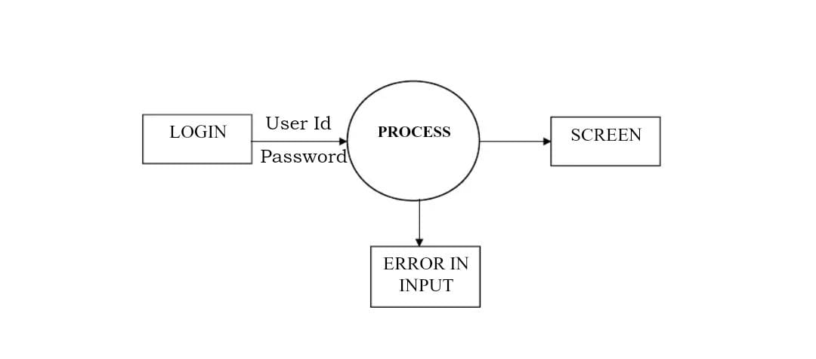

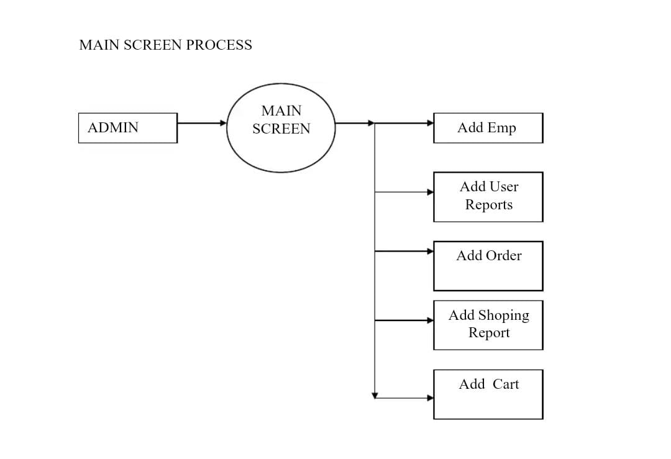

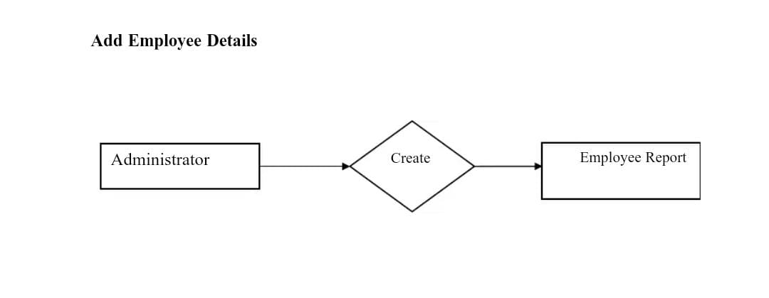

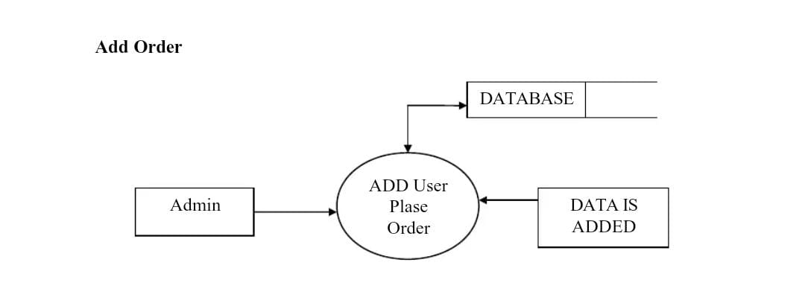

**4.2.DATABASE DESIGN**

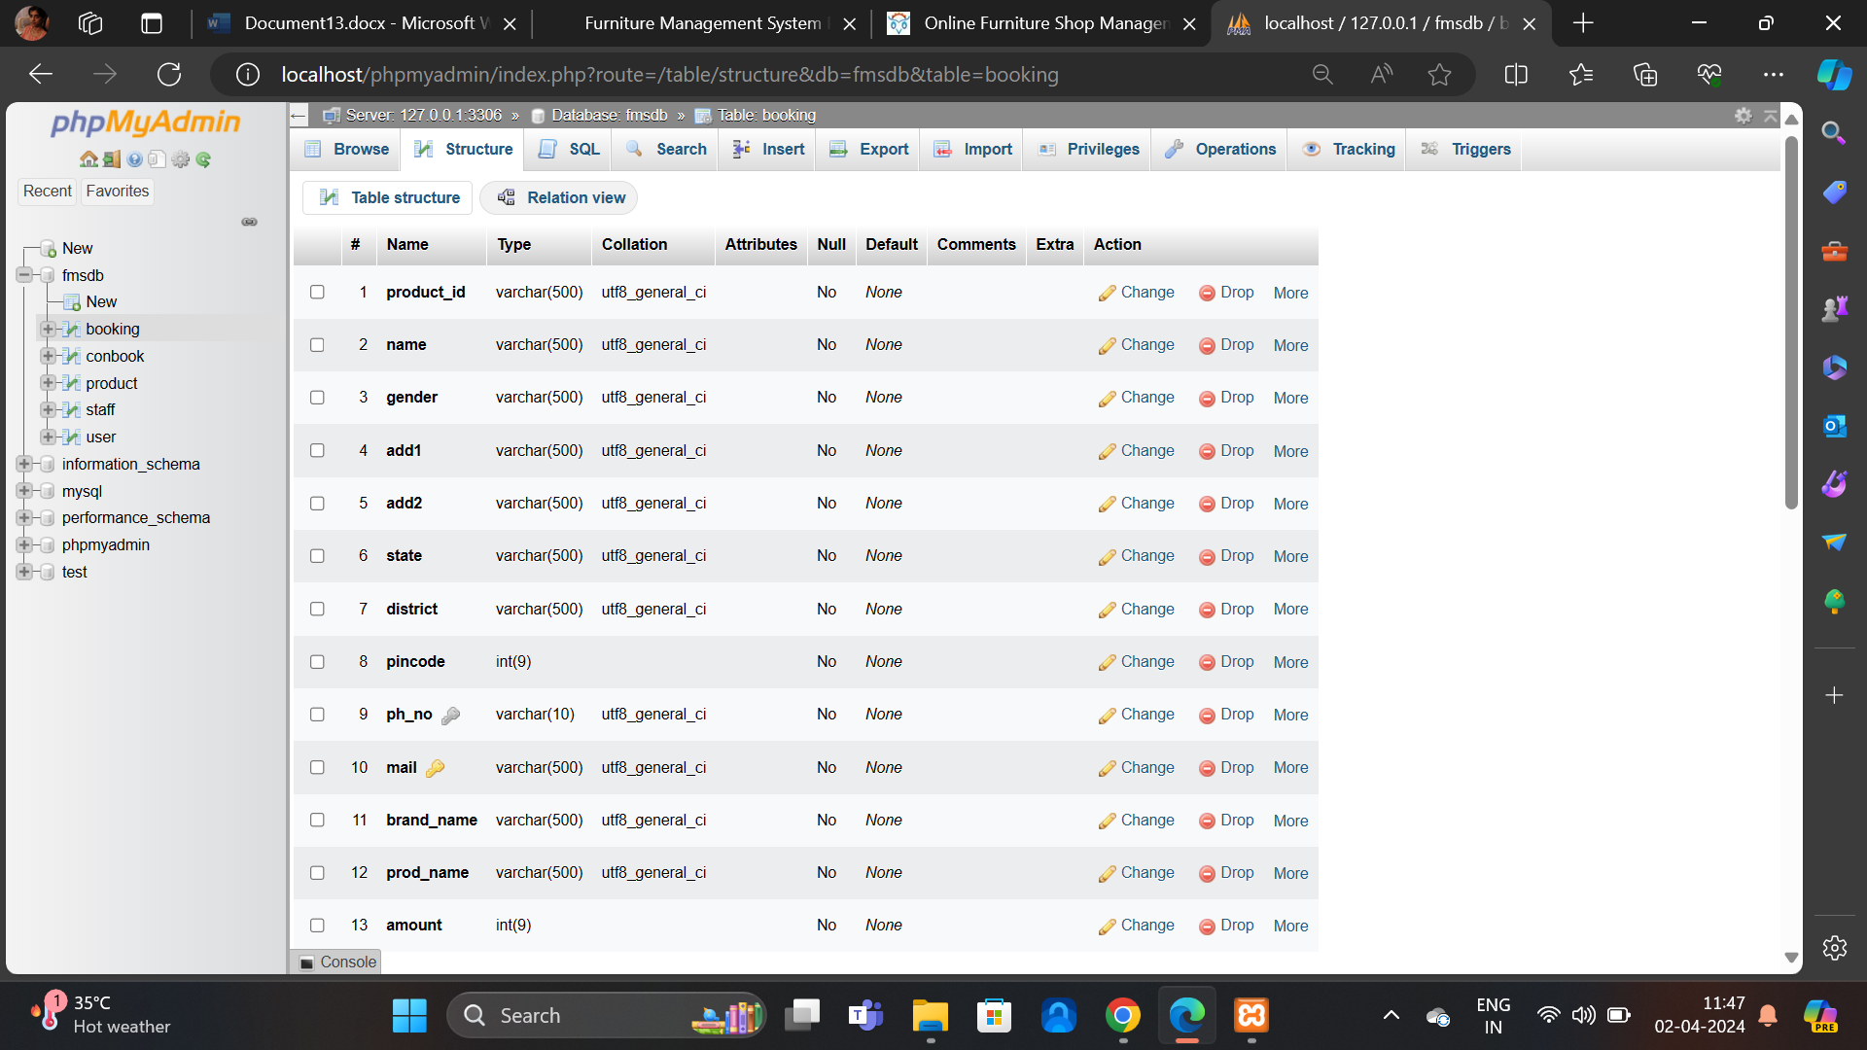

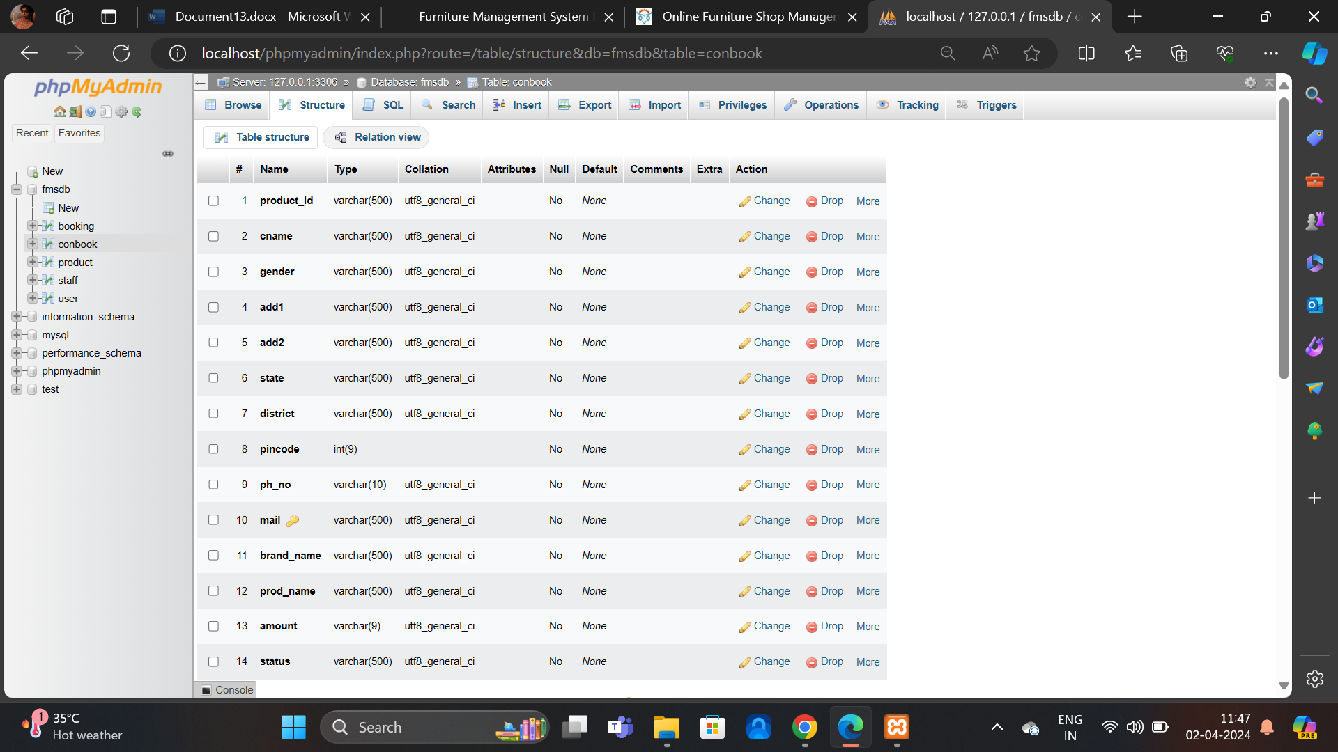

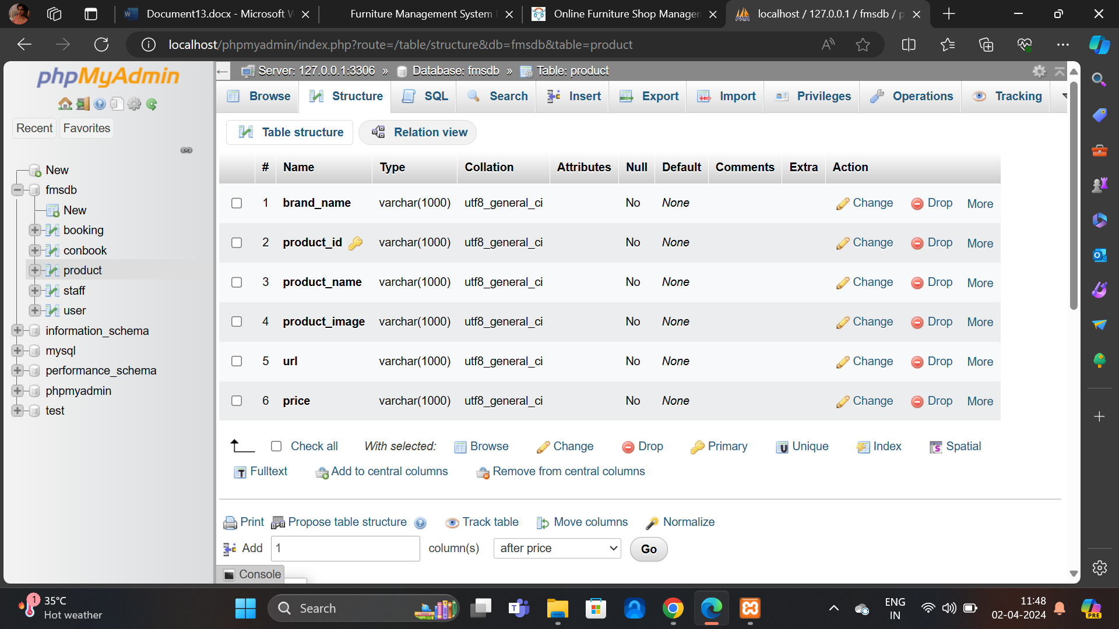

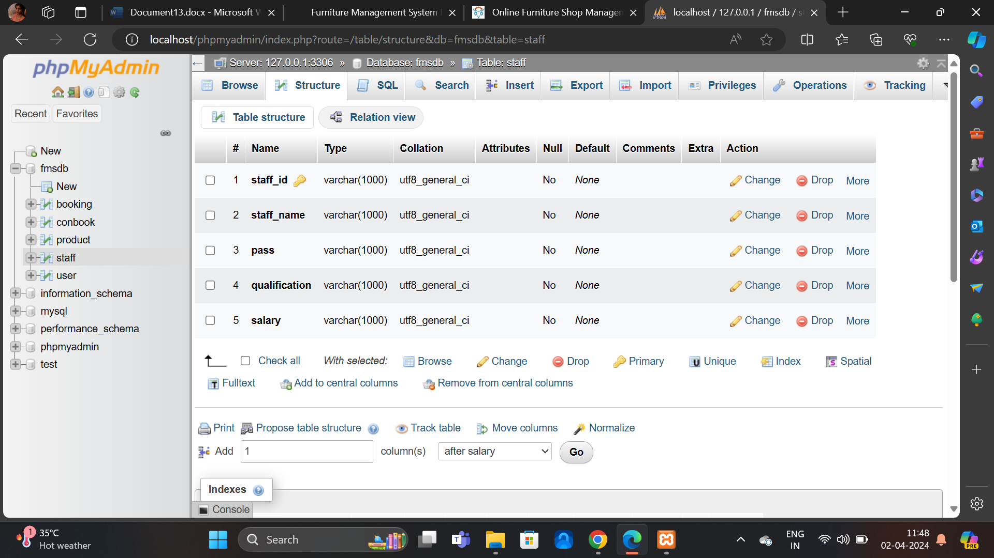

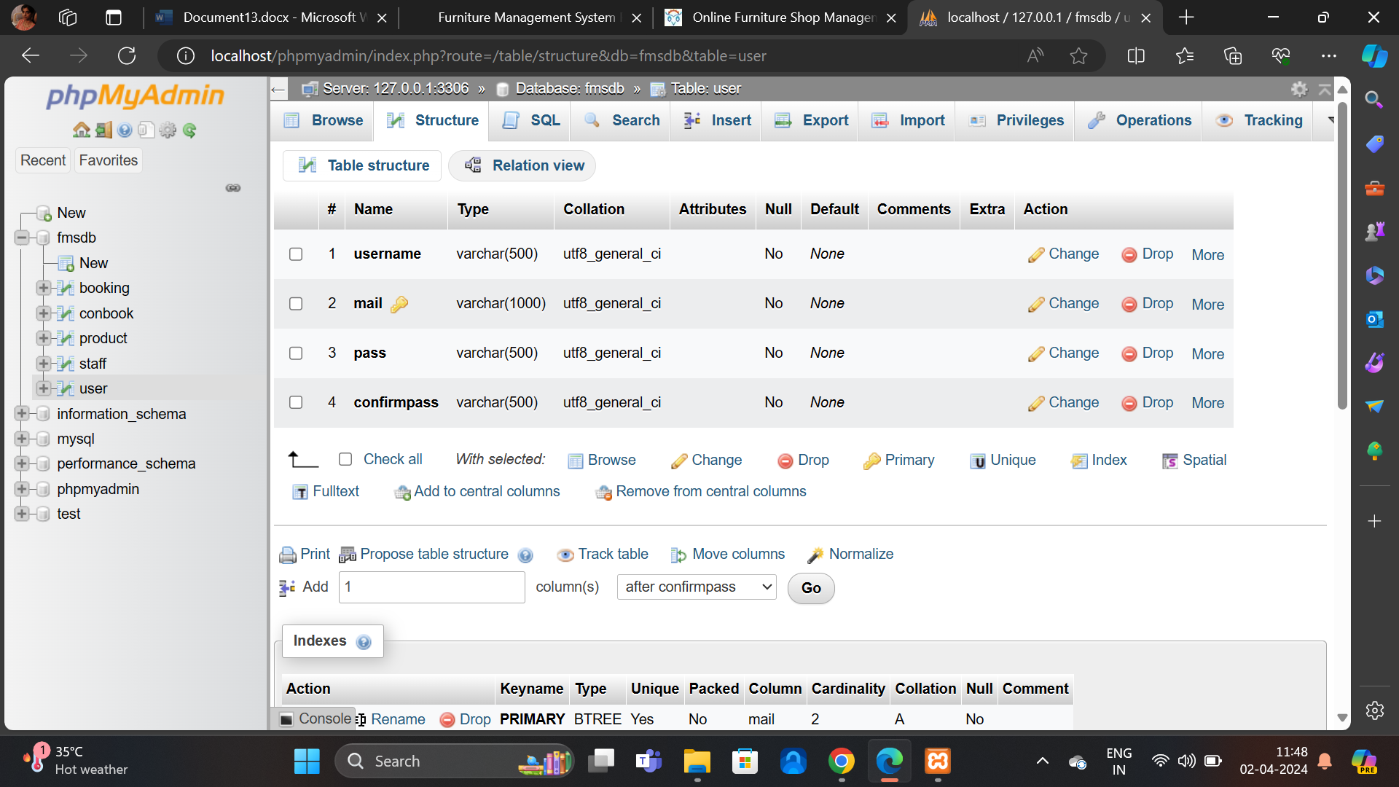

**5.SYSTEM TESTING**

**TESTING OBJECTIVE**

Software testing is an important phase in the development of the system. Generally, system testing involves testing integration of each module in the system. The objective while testing the system is to test the discrepancies between the system and the original objective. The quality of an information system depends on its design, development and implementation. Testing is the most important activity in the development phase. Testing is the process of finding errors or bugs in the system. Testing ensure that the user’s needs are satisfied. In other words it is a process by which one detects the defects in the system.

• Unit testing

• Integration testing

**5.1 UNIT TESTING**

Unit testing is undertaken when a module has been created and successfully reviewed .In order to test a single module we need to provide a complete environment i.e., besides the module we would require

• The procedures belonging to other modules that the module under test calls

• Non local data structures that module accesses

• A procedure to call the functions of the module under test with appropriate parameters.

**5.2 INTEGRATION TESTING**

In this type of testing we test various integration of the project module by providing the input. The primary objective is to test the module interfaces in order to ensure that no errors are occurring when one module invokes the other module.

**6.SYSTEM IMPLEMENTATION**

Learning reveals a lot about what to expect from students generally following implementation and upkeep After implementation, every operating system needs to undergo a post-implementation evaluation.

A study of the implementation compares the system's performance to predetermined standards. It is after the fact, after conversion and design are finished. Additionally, it offers details to help you decide whether a substantial design is required. Maintenance is development's riddle. It tries up programming resources while holding the software industry prisoner. Programmer spends more time maintaining program then they do write them.

• Conversion: To convert is to switch from one system to another. The goal is to put the to the test system operational by minimizing costs, hazards, and employee annoyance

• Training: Two aspects are the main focus of a user training analysis. Capabilities of the user and the nature of the installing a system. Users can range from the most basic to the most advanced

The users can login to our website and can book the Project management of their choice, if they are new users they can sign in to our website and can book their Project for getting information. The admin can view customer details, edit the and candies into our website for the customer to view and book the Project.

**7.CONCLUSIONS**

The package was designed in such a way that future modifications can bedone easily. The following conclusions can be deduced from the development of the project.

Automation of the entire system improves the efficiency

It provides a friendly graphical user interface which proves to be better when compared to the existing system.

It gives appropriate access to the authoried users depending on their permissions.

It effectively overcomes the delay in communications.

Updating of information becomes so easier.

System security, data security and reliability are the striking features.

The System has adequate scope for modification in future if it is necessary

**8.APPENDIX**

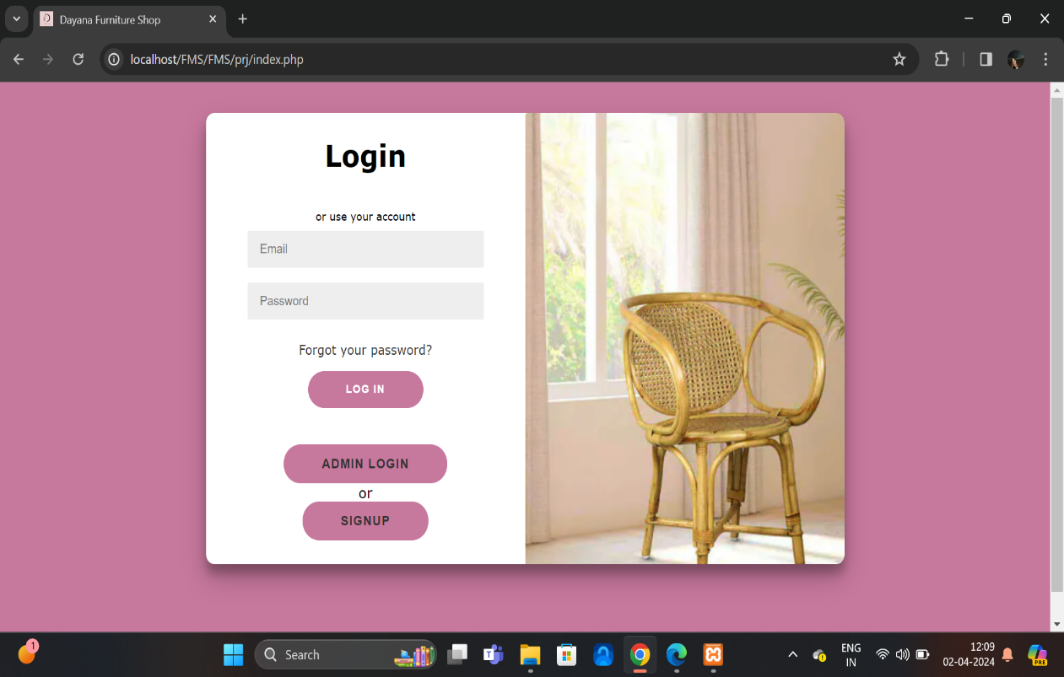

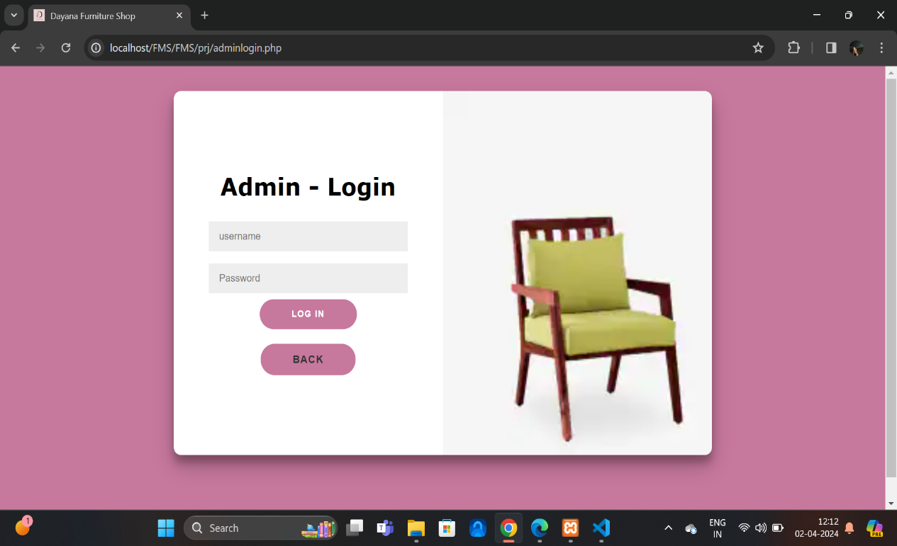

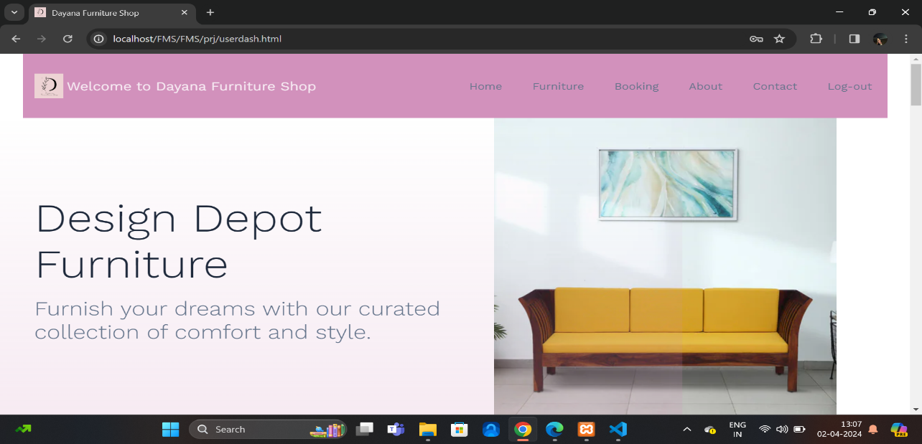

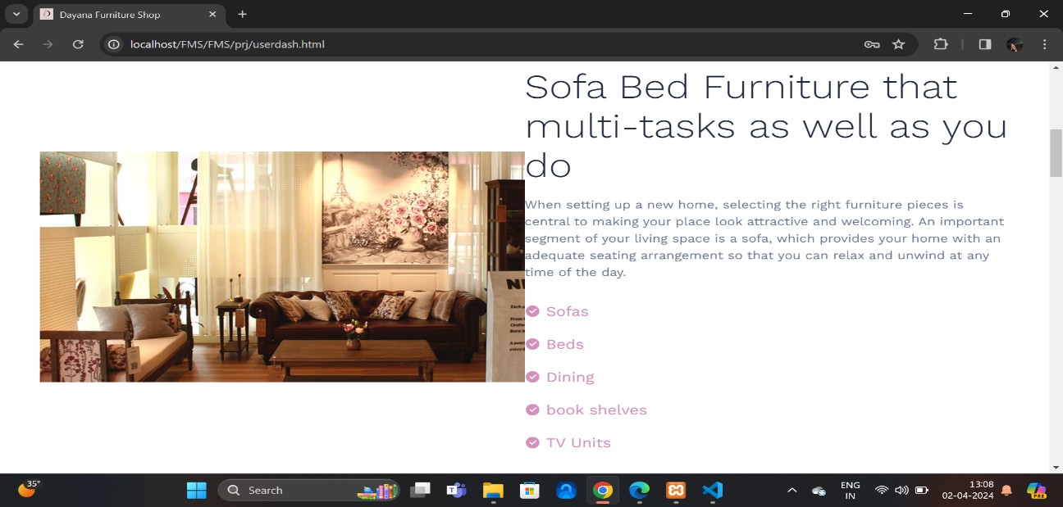 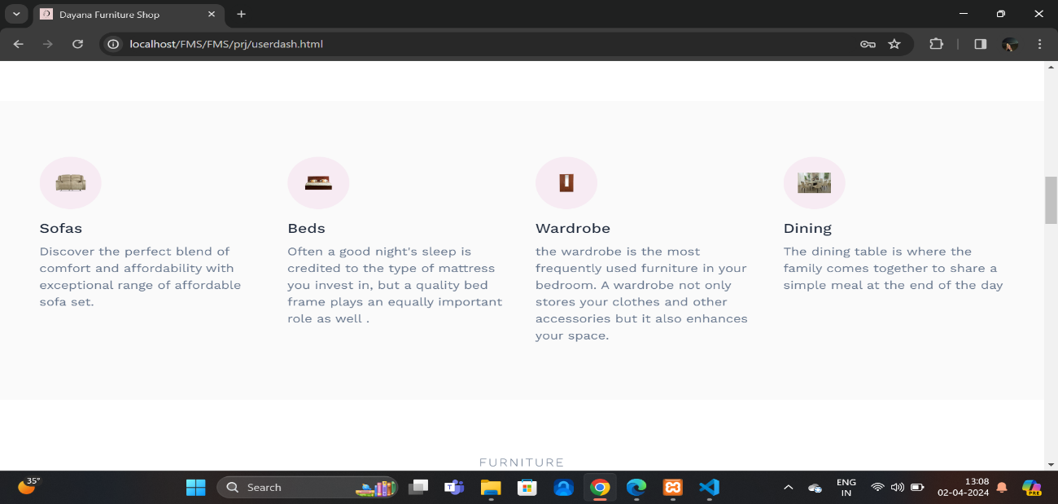

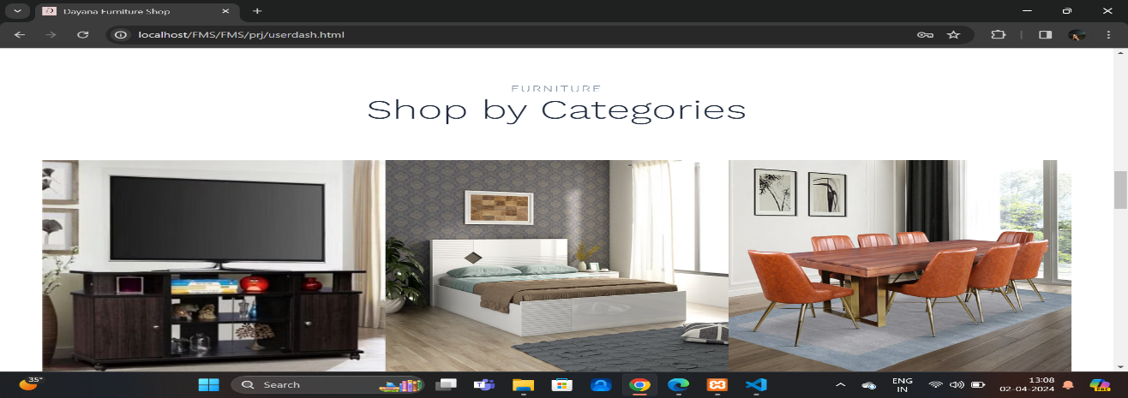 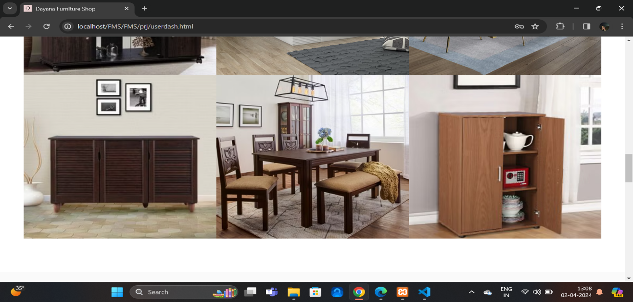

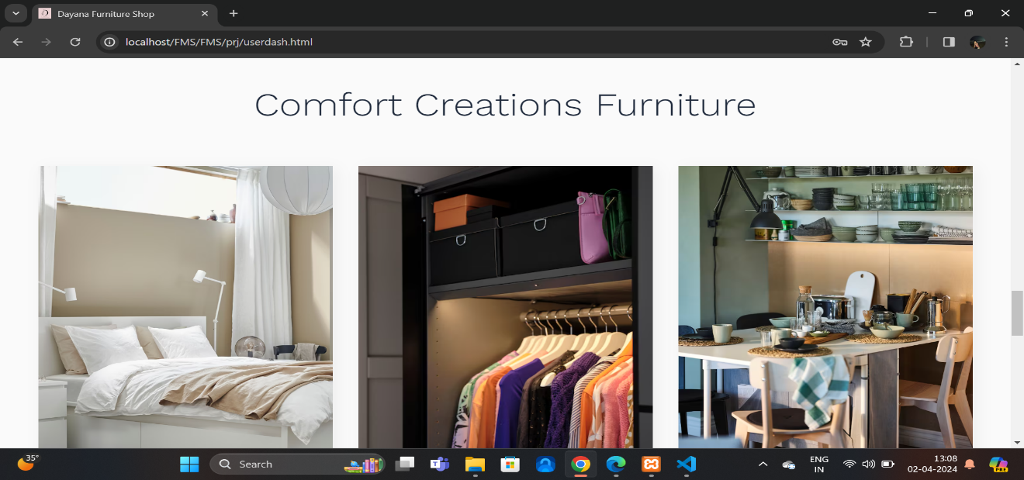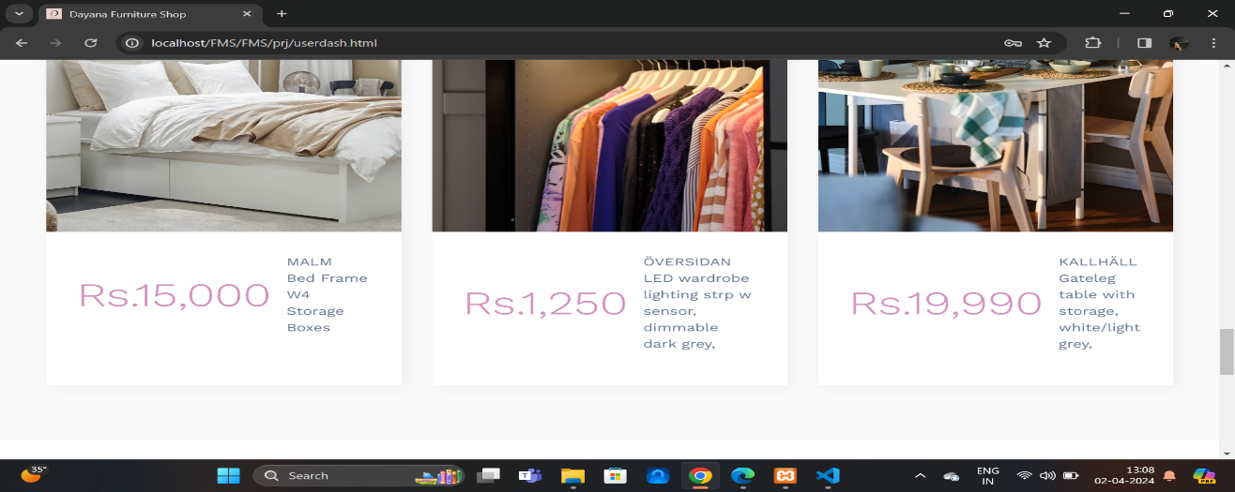

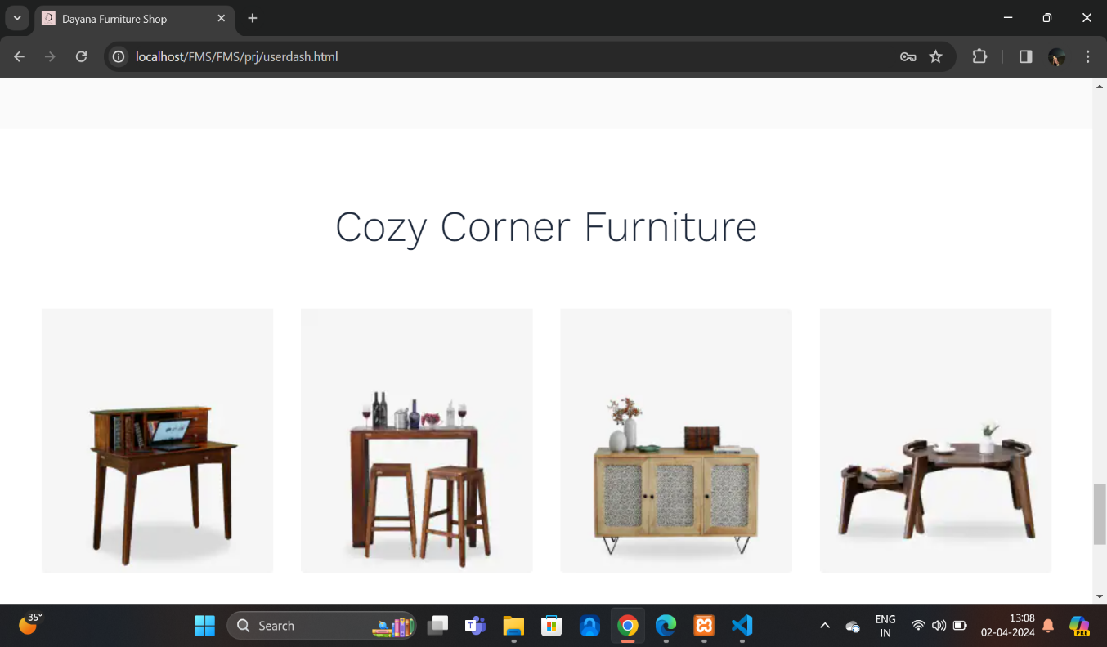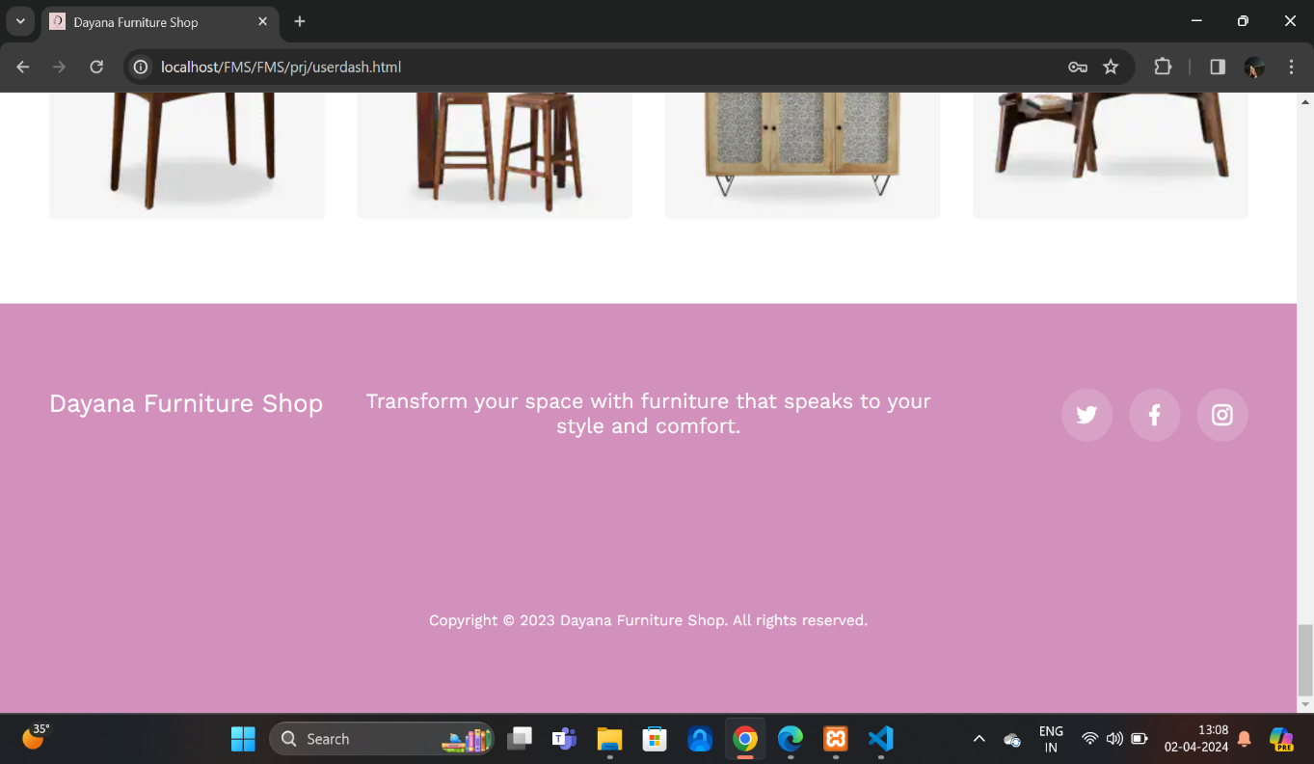

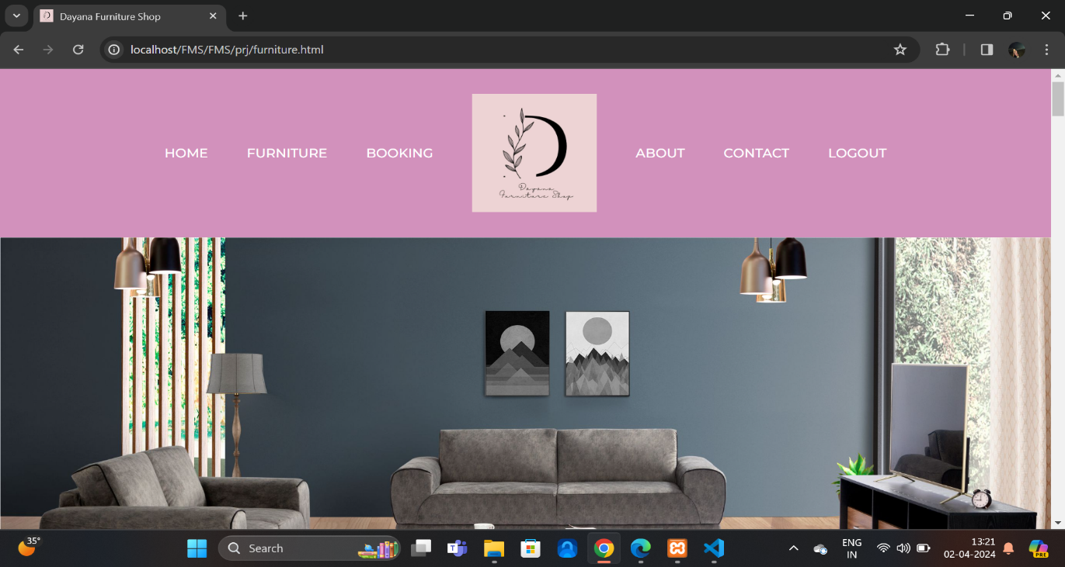

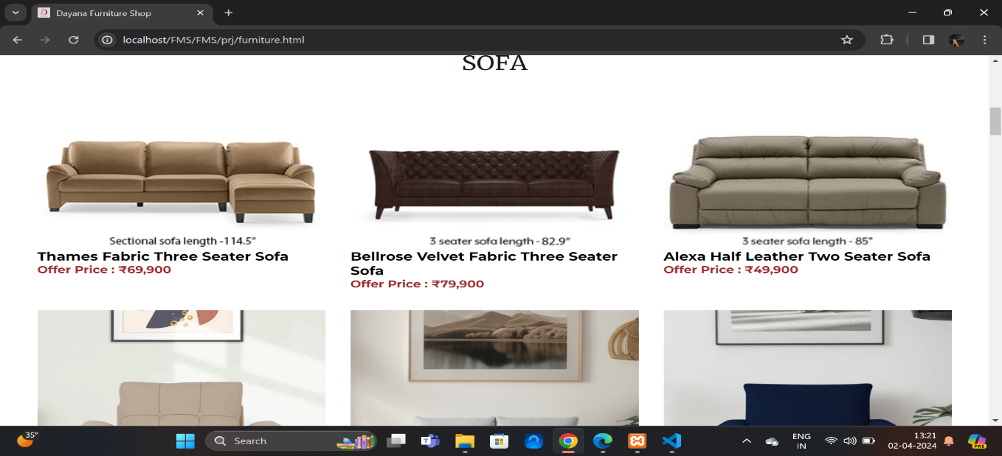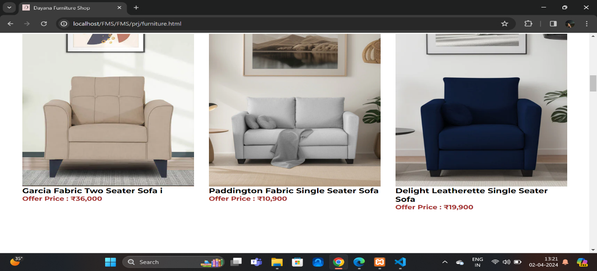

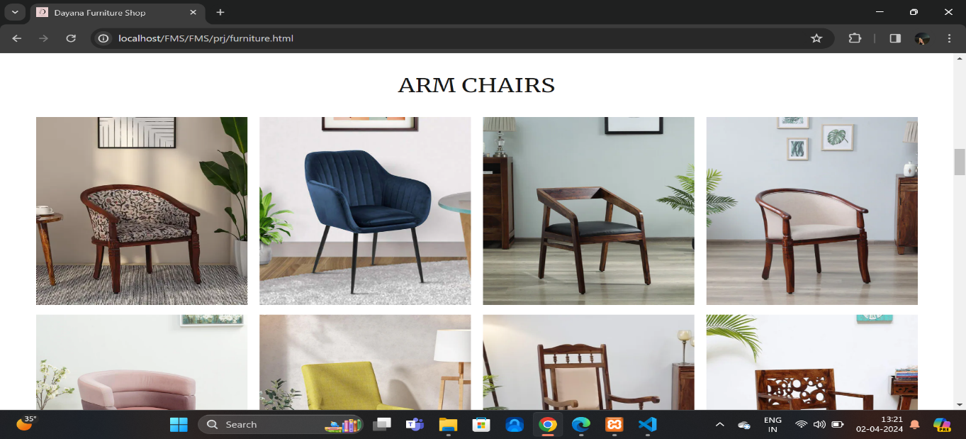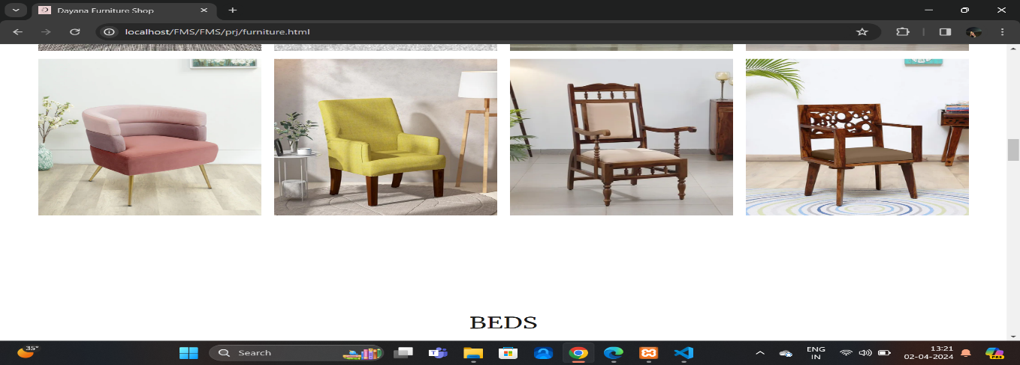

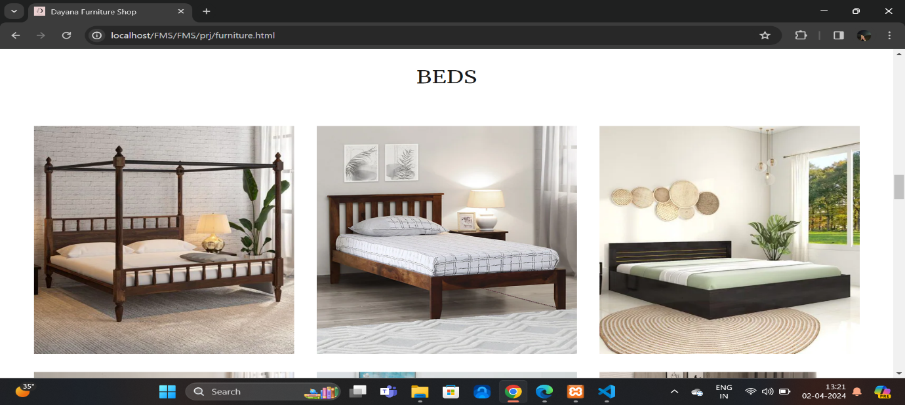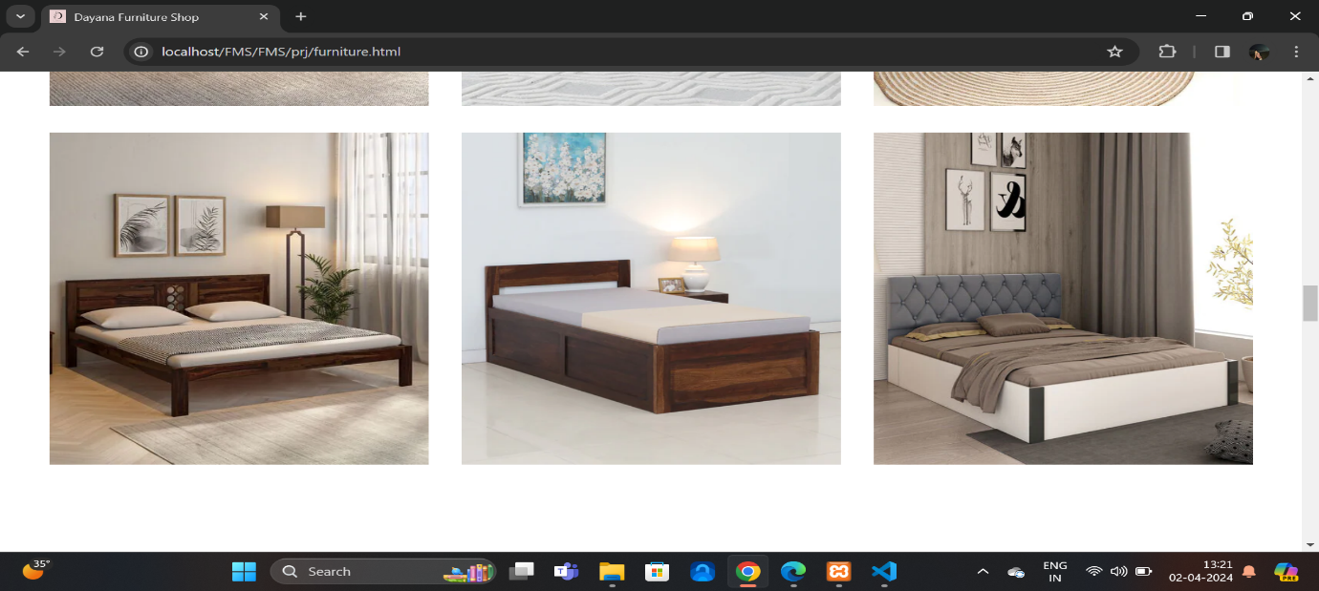

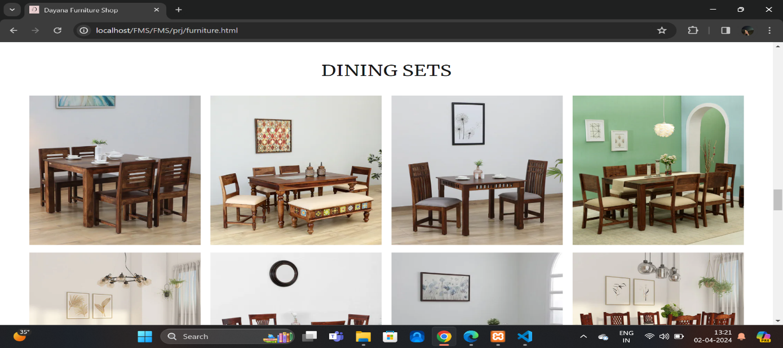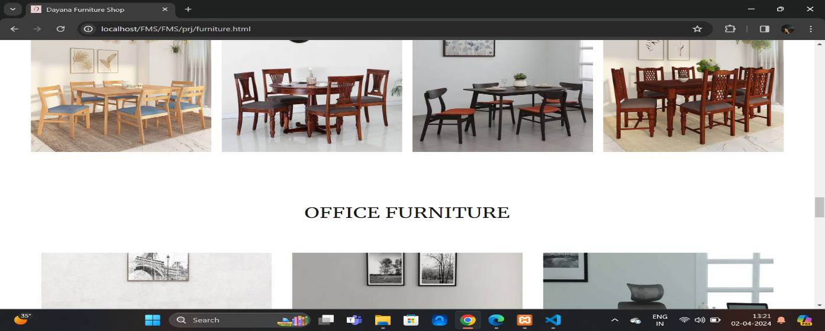

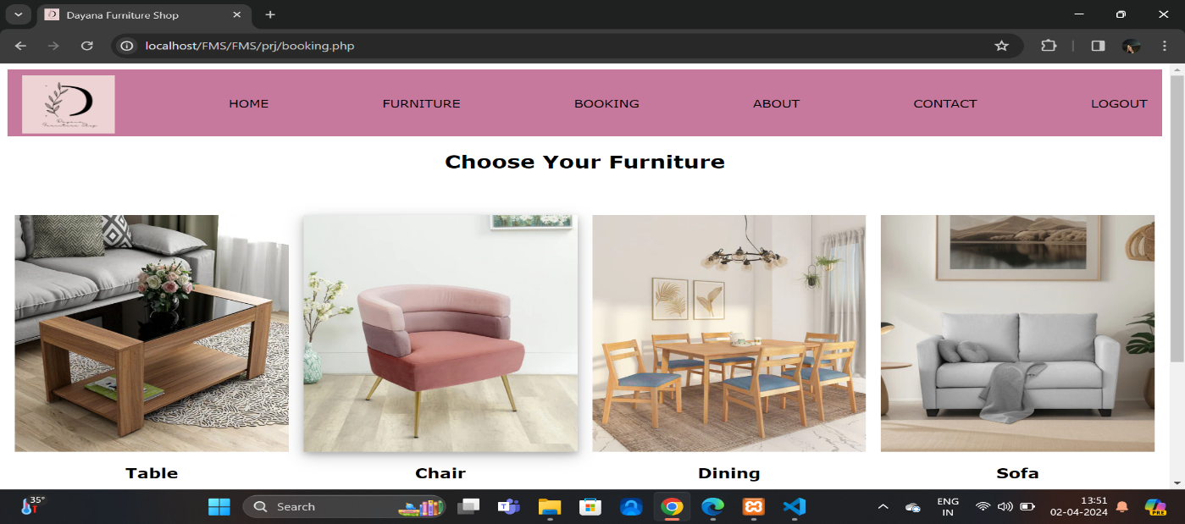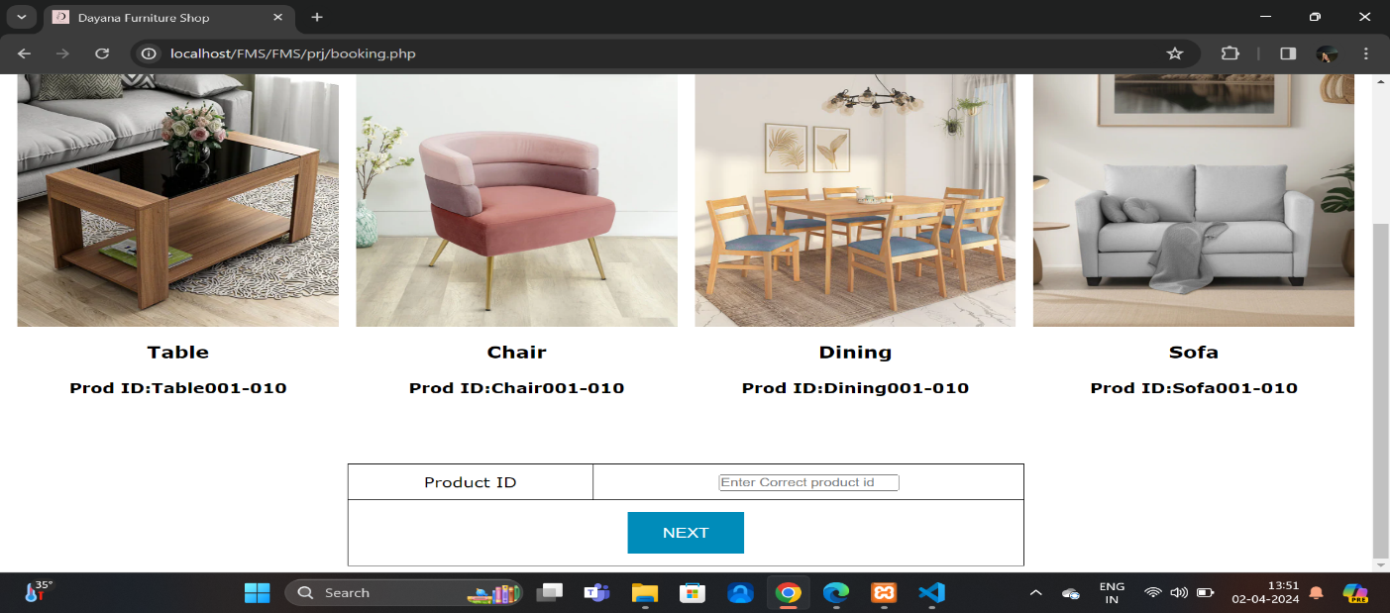

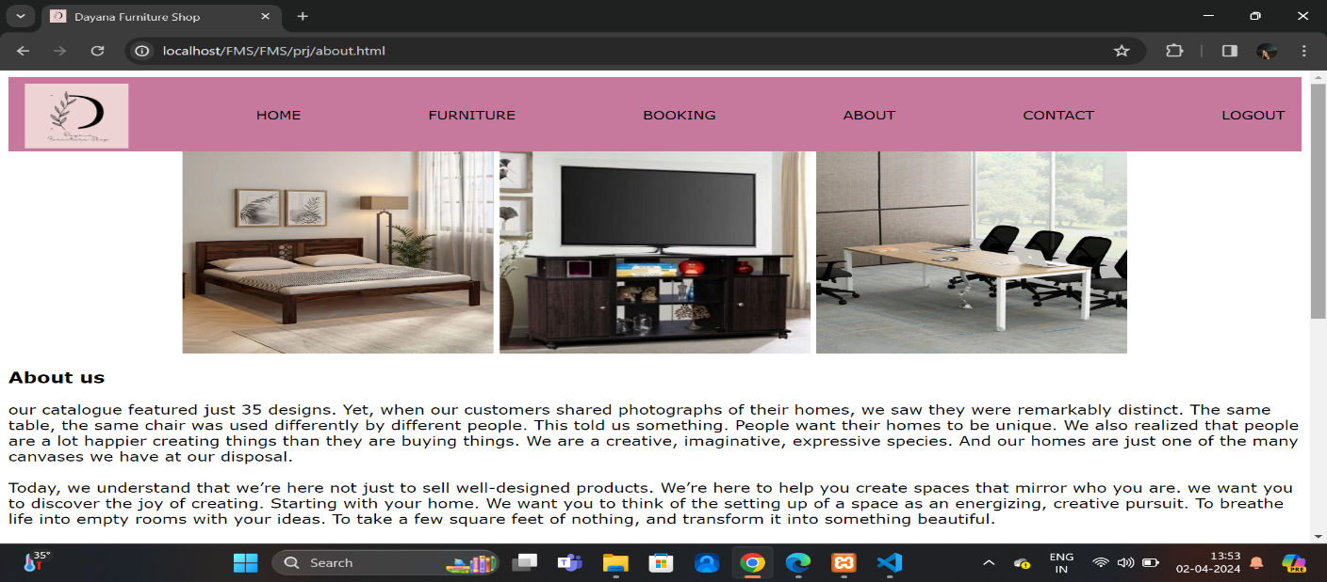

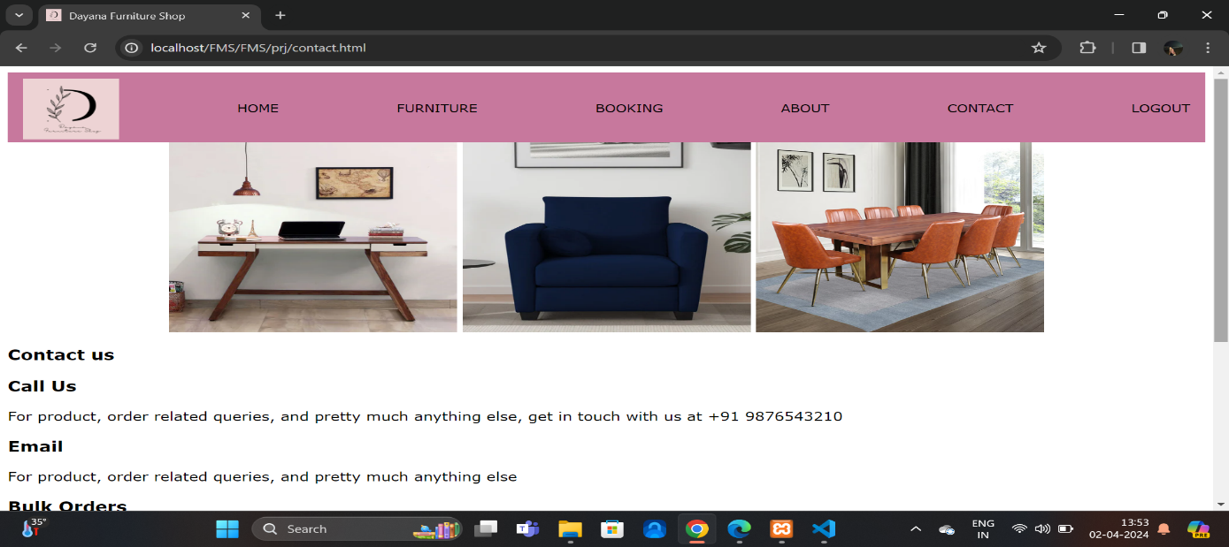

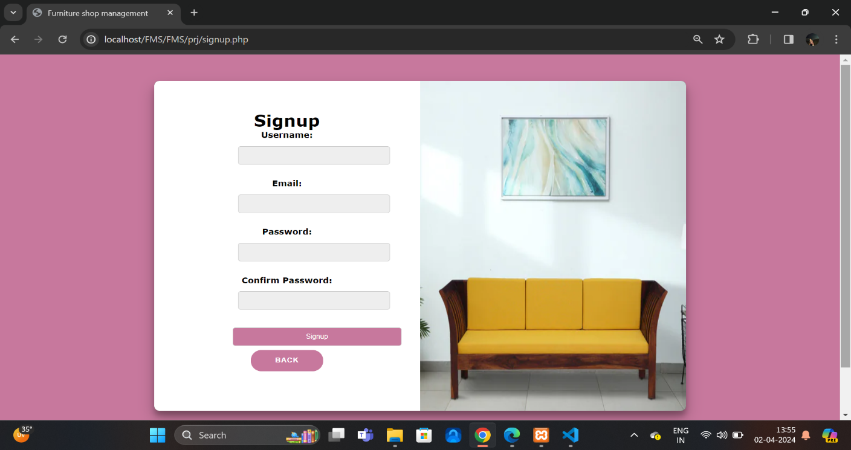

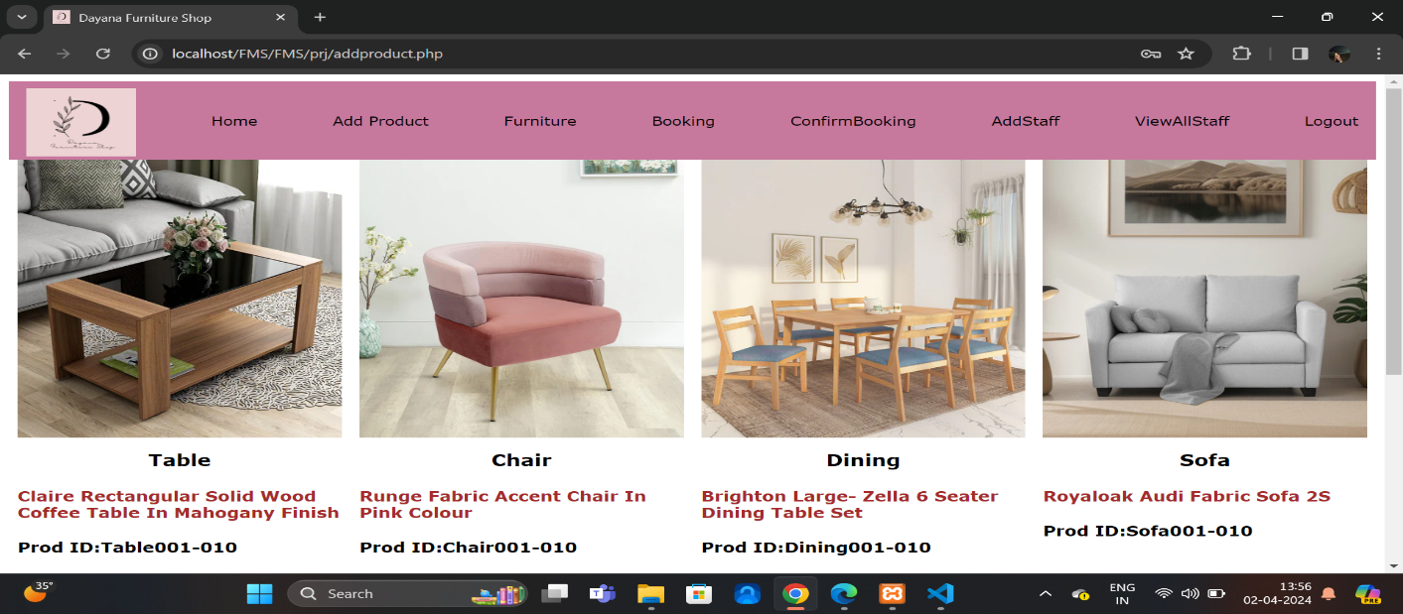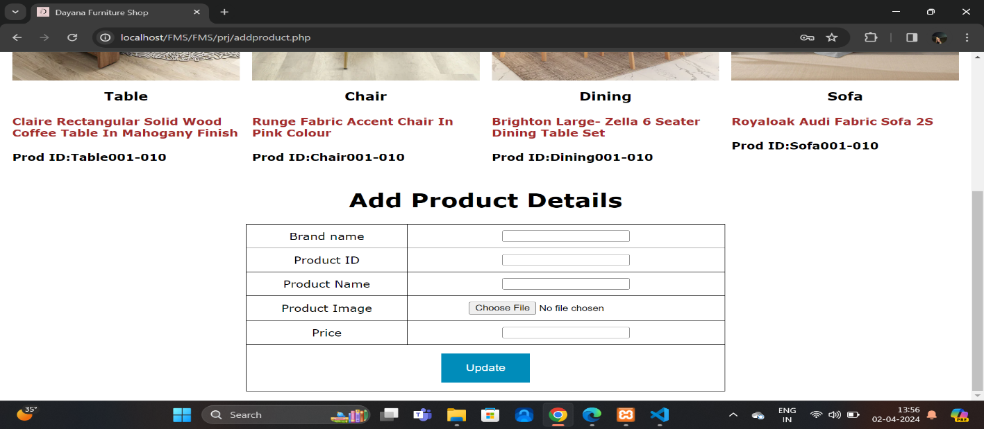

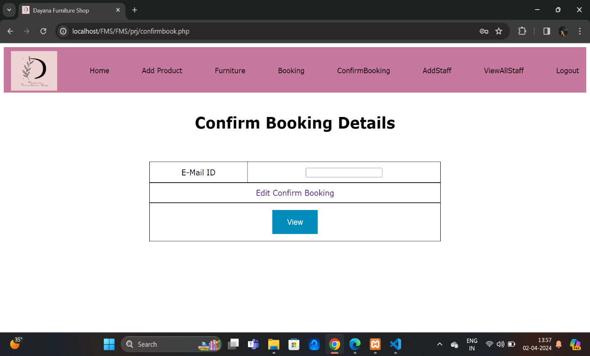

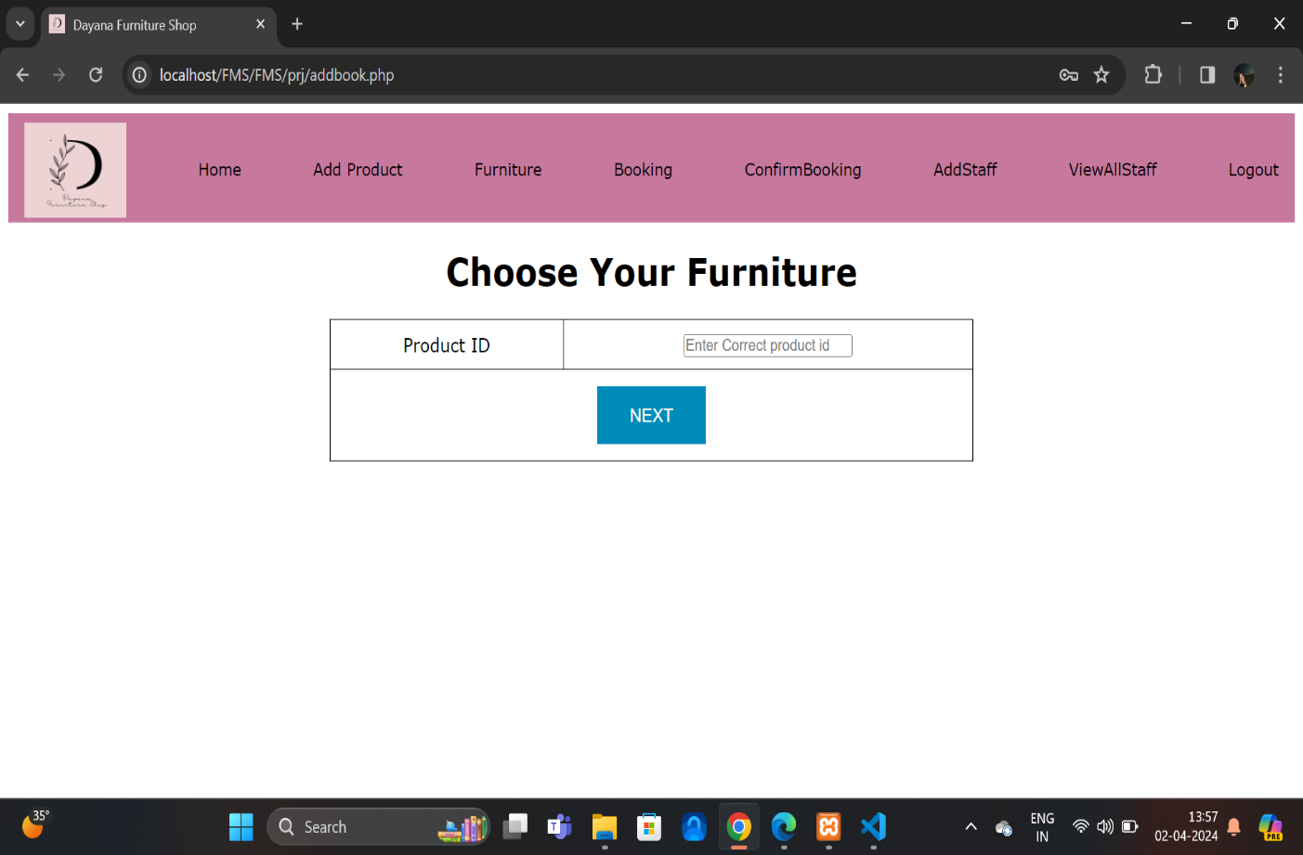

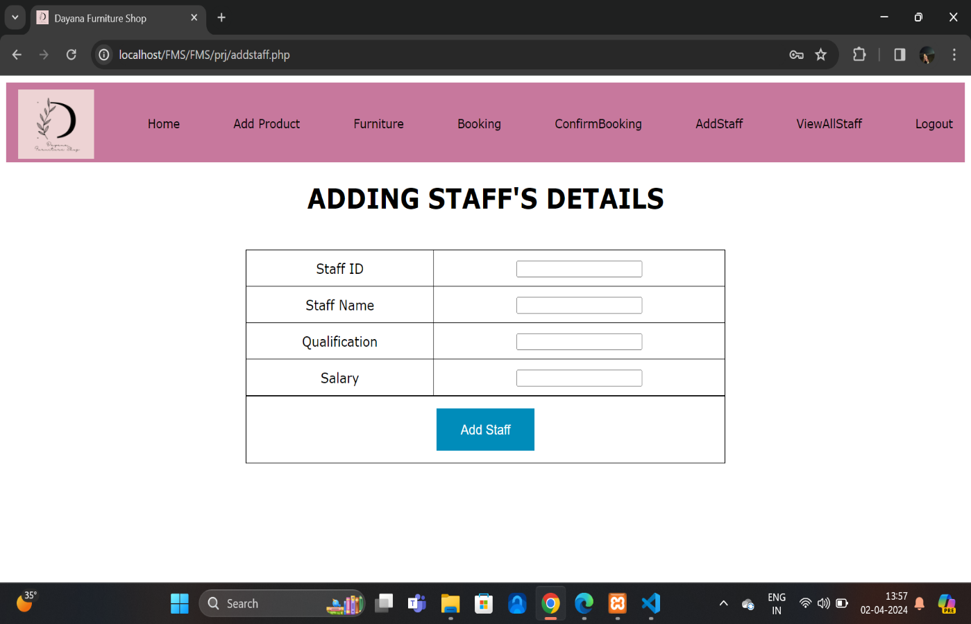

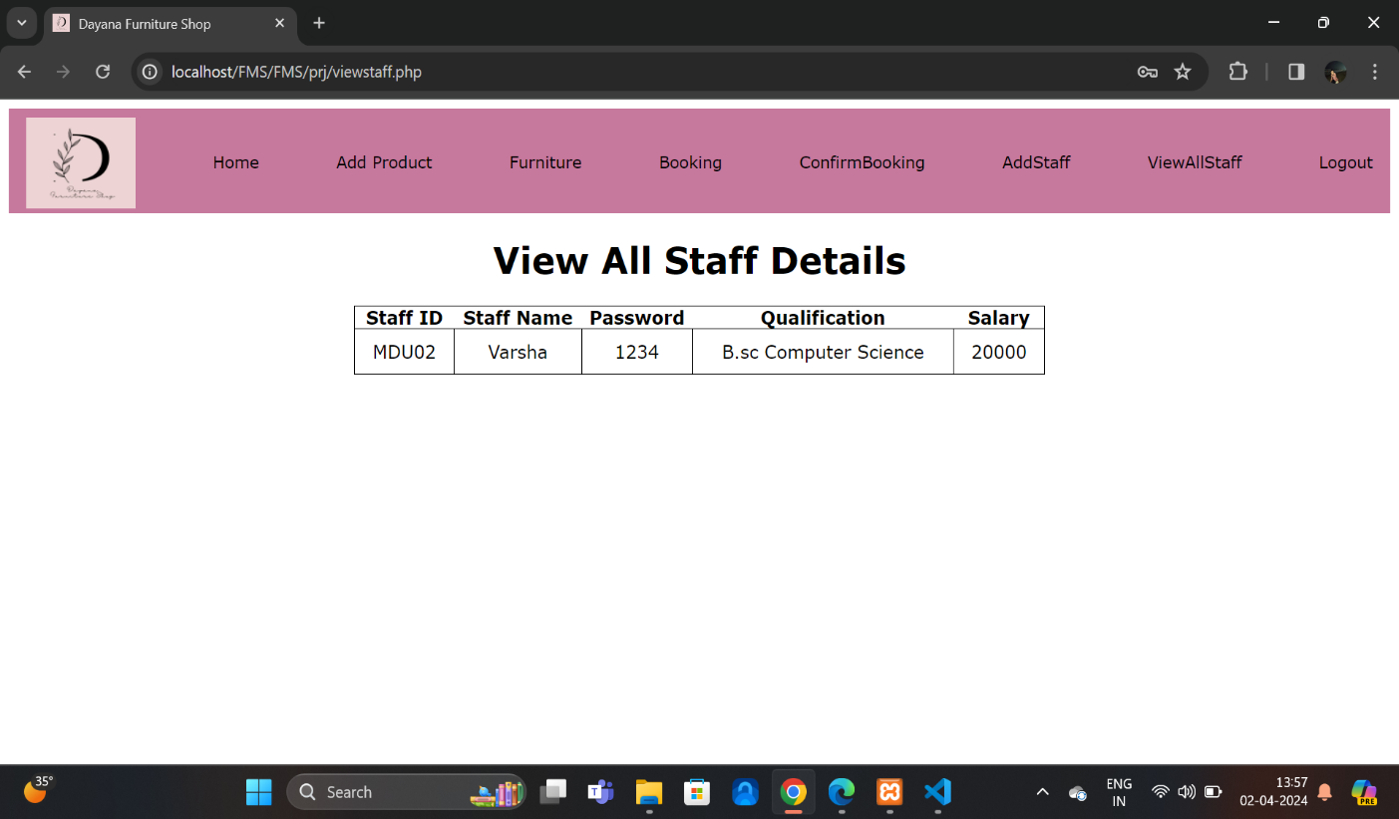

**8.2.SOURCE CODE**

<!DOCTYPE html>

<html lang="en">

<head>

<meta charset="UTF-8">

<meta name="viewport" content="width=device-width, initial-scale=1.0">

<title> Furniture shop management</title>

<link rel="shortcut icon" href="./images/d logo.jpg" type="image/x-icon">

<link rel="stylesheet" href="./css/signup.css">

</head>

<body>

<div class="container" id="container">

<div class="form-container log-in-container">

<form action="" method="post">

<h1>Signup</h1>

<div class="form-group">

<label for="username">Username:</label>

<input type="text" id="username" name="username" >

</div>

<div class="form-group">

<label for="email">Email:</label>

<input type="email" id="email" name="email" >

</div>

<div class="form-group">

<label for="password">Password:</label>

<input type="password" id="password" name="password" >

</div>

<div class="form-group">

<label for="confirm_password">Confirm Password:</label>

<input type="password" id="confirm_password" name="confirm_password" >

</div>

<div class="form-group">

<input type="submit" value="Signup" name="sub">

<button><a href="index.php">Back</a></button>

</div>

</form>

</div>

<div class="overlay-container">

<img src="./images/signup pic.webp" alt="" width="500" height="750">

</div>

</div>

</div>

<?php

if(isset($_POST['sub']))

{

$username=$_POST['username'];

$email=$_POST['email'];

$password=$_POST['password'];

$confirmpass=$_POST['confirm_password'];

if(($username=="")||($email=="")||($password=="")||($confirmpass==""))

{

echo("<script>alert('Fill All Detail')</script>");

}

else

{

$con=mysqli_connect("localhost","root","athish123","fmsdb");

$sql="INSERT INTO user VALUES('$username','$email','$password','$confirmpass')";

mysqli_query($con,$sql);

echo("<script>alert('Record Is Added Successfully')</script>");

}

}

?>

</body>

</html>

<!DOCTYPE html>

<html lang="en">

<head>

<meta charset="UTF-8">

<meta name="viewport" content="width=device-width, initial-scale=1.0">

<title>Dayana Furniture Shop</title>

<link rel="stylesheet" href="booking.css">

<link rel="shortcut icon" href="./images/d logo.jpg" type="image/x-icon">

</head>

<body>

<nav>

<div class="section__container nav__links">

<img src="./images/d logo.jpg" alt="" width="100" height="80">

<span><a href="adminindex.html">Home</a></span>

<span><a href="addproduct.php">Add Product</a></span>

<span><a href="adminFurniture.html">Furniture</a></span>

<span><a href="addbook.php">Booking</a></span>

<span><a href="confirmbook.php">ConfirmBooking</a></span>

<span><a href="addstaff.php">AddStaff</a></span>

<span><a href="viewstaff.php">ViewAllStaff</a></span>

<span><a href="index.php">Logout</a></span>

</div>

</nav>

<center><h1>Choose Your Furniture </h1></center>

<table border="1" align="center">

<form action="addbook2.php" method="post">

<tr>

<td>Product ID</td>

<td><input type="text" name="proid" placeholder="Enter Correct product id " ></td>

</tr>

<tr >

<td colspan="2"><center><button class="button" type="submit" name="sub">NEXT</button></center></td>

</tr>

</form>

</table>

</body>

</html>

<!DOCTYPE html>

<html lang="en">

<head>

<meta charset="UTF-8">

<meta name="viewport" content="width=device-width, initial-scale=1.0">

<title>Dayana Furniture Shop</title>

<link rel="shortcut icon" href="./images/d logo.jpg" type="image/x-icon">

<link rel="stylesheet" href="./css/furniture.css">

</head>

<body>

<header class="header" id="home">

<nav>

<div class="section__container nav__links">

<img src="./images/d logo.jpg" alt="" width="100" height="80">

<span><a href="adminindex.html">Home</a></span>

<span><a href="addproduct.php">Add Product</a></span>

<span><a href="furniture.html">Furniture</a></span>

<span><a href="addbook.php">Booking</a></span>

<span><a href="confirmbook.php">ConfirmBooking</a></span>

<span><a href="addstaff.php">AddStaff</a></span>

<span><a href="viewstaff.php">ViewAllStaff</a></span>

<span><a href="index.php">Logout</a></span>

</div>

</nav>

<img src="./images/banner 1.jpg" alt="">

</header>

<div class="section__container portfolio__container">

<h2 class="section__header">SOFA</h2><br>

<div class="portfolio__grid">

<div class="portfolio__card">

<img src="./images/Sofa 1.png" alt="portfolio" />

</div>

<div class="portfolio__card">

<img src="./images/Sofa 2.png" alt="portfolio" />

</div>

<div class="portfolio__card">

<img src="./images/Sofa 3.jpg" alt="portfolio" />

</div>

<div class="portfolio__card">

<img src="./images/Sofa 4.webp" alt="portfolio" />

</div>

<div class="portfolio__card">

<img src="./images/sofa 5.webp" alt="portfolio" />

</div>

<div class="portfolio__card">

<img src="./images/sofa 6.webp" alt="portfolio" />

</div>

</div>

</div>

<section class="section__container gallery__container">

<h2 class="section__header">ARM CHAIRS</h2>

<div class="gallery__grid">

<img src="./images/chair 1.webp" alt="gallery" />

<img src="./images/chair 2.webp" alt="gallery" />

<img src="./images/chair 3.webp" alt="gallery" />

<img src="./images/chair 4.webp" alt="gallery" />

<img src="./images/chair 5.webp" alt="gallery" />

<img src="./images/chair 6.webp" alt="gallery" />

<img src="./images/chair 7.webp" alt="gallery" />

<img src="./images/chair 8.webp" alt="gallery" />

</div>

</section>

<div class="section__container portfolio__container">

<h2 class="section__header">BEDS</h2><br>

<div class="portfolio__grid">

<div class="portfolio__card">

<img src="./images/bed 1.webp" alt="portfolio" />

</div>

<div class="portfolio__card">

<img src="./images/bed 2.webp" alt="portfolio" />

</div>

<div class="portfolio__card">

<img src="./images/bed 3.webp" alt="portfolio" />

</div>

<div class="portfolio__card">

<img src="./images/bed 4.webp" alt="portfolio" />

</div>

<div class="portfolio__card">

<img src="./images/bed 5.webp" alt="portfolio" />

</div>

<div class="portfolio__card">

<img src="./images/bed 6.webp" alt="portfolio" />

</div>

</div>

</div>

<section class="section__container gallery__container">

<h2 class="section__header">DINING SETS</h2>

<div class="gallery__grid">

<img src="./images/dining 1.webp" alt="gallery" />

<img src="./images/dining 2.webp" alt="gallery" />

<img src="./images/dining 3.webp" alt="gallery" />

<img src="./images/dining 4.webp" alt="gallery" />

<img src="./images/dining 5.webp" alt="gallery" />

<img src="./images/dining 6.webp" alt="gallery" />

<img src="./images/dining 7.webp" alt="gallery" />

<img src="./images/dining 8.webp" alt="gallery" />

</div>

<div class="section__container portfolio__container">

<h2 class="section__header">OFFICE FURNITURE</h2><br>

<div class="portfolio__grid">

<div class="portfolio__card">

<img src="./images/office 1.webp" alt="portfolio" />

</div>

<div class="portfolio__card">

<img src="./images/office 2.webp" alt="portfolio" />

</div>

<div class="portfolio__card">

<img src="./images/office 3.webp" alt="portfolio" />

</div>

<div class="portfolio__card">

<img src="./images/office 4.webp" alt="portfolio" />

</div>

<div class="portfolio__card">

<img src="./images/office 5.webp" alt="portfolio" />

</div>

<div class="portfolio__card">

<img src="./images/office 6.webp" alt="portfolio" />

</div>

</div>

</div>

<section class="section__container gallery__container">

<h2 class="section__header">TABLES</h2>

<div class="gallery__grid">

<img src="./images/table 1.webp" alt="gallery" />

<img src="./images/table 2.webp" alt="gallery" />

<img src="./images/table 3.webp" alt="gallery" />

<img src="./images/table 4.webp" alt="gallery" />

<img src="./images/table 5.webp" alt="gallery" />

<img src="./images/table 6.webp" alt="gallery" />

<img src="./images/table 7.webp" alt="gallery" />

<img src="./images/table 8.webp" alt="gallery" />

</div>

<section class="section__container instagram__container">

<h2 class="section__header">Explore Our Furniture</h2>

<div class="instagram__flex">

<img src="./images/sofa 4.jpg" alt="instagram" />

<img src="./images/5 categ.avif" alt="instagram" />

<img src="./images/chair 2.webp" alt="instagram" />

<img src="./images/photo 3.webp" alt="instagram" />

<img src="./images/sofa 5.webp" alt="instagram" />

<img src="./images/Wardrobes.avif" alt="instagram" />

<img src="./images/photo 4.webp" alt="instagram" />

<img src="./images/sofa 6.webp" alt="instagram" />

</div>

</section>

<footer id="contact">

<div class="section__container footer__container">

<div class="footer__col">

<img src="./images/d logo.jpg" alt="logo" />

<div class="footer__socials">

<a href="#"><i class="ri-facebook-fill"></i></a>

<a href="#"><i class="ri-instagram-line"></i></a>

<a href="#"><i class="ri-twitter-fill"></i></a>

<a href="#"><i class="ri-youtube-fill"></i></a>

<a href="#"><i class="ri-pinterest-line"></i></a>

</div>

</div>

<div class="footer__col">

<h4>STAY IN TOUCH</h4>

<p>

Experience the art of living with our handpicked furniture pieces

</p>

</div>

</div>

</footer>

<script src="https://unpkg.com/scrollreveal"></script>

<script src="https://cdn.jsdelivr.net/npm/swiper@11/swiper-bundle.min.js"></script>

<script src="furniture.js"></script>

</body>

</html>

<!DOCTYPE html>

<html lang="en">

<head>

<meta charset="UTF-8">

<meta name="viewport" content="width=device-width, initial-scale=1.0">

<title>Dayana Furniture Shop</title>

<link rel="stylesheet" href="userdash.css">

<link rel="shortcut icon" href="./images/d logo.jpg" type="image/x-icon">

<link

href="https://cdn.jsdelivr.net/npm/remixicon@3.5.0/fonts/remixicon.css"

rel="stylesheet"

/>

<script src="https://unpkg.com/scrollreveal"></script>

</head>

<body>

<nav>

<div class="nav__logo">

<img src="./images/d logo.jpg" alt="logo" />

</div>

<ul class="nav__links">

<li class="link"><a href="adminindex.html">Home</a></li>

<li class="link"><a href="addproduct.php">Add Product</a></li>

<li class="link"><a href="adminFurniture.html">Furniture</a></li>

<li class="link"><a href="addbook.php">Booking</a></li>

<li class="link"><a href="confirmbook.php">ConfirmBooking</a></li>

<li class="link"><a href="viewbook.php">ViewAllBooking</a></li>

<li class="link"><a href="addstaff.php">AddStaff</a></li>

<li class="link"><a href="viewstaff.php">ViewAllStaff</a></li>

<li class="link"><a href="index.php">Logout</a></li>

</ul>

</nav>

<header id="home">

<div class="section__container header__container">

<div class="header__content">

<h1>Design Depot Furniture</h1>

<h2>Furnish your dreams with our curated collection of comfort and style.</h2>

<!-- <button class="btn">15 Days free trial</button> -->

</div>

<div class="header__image">

<img src="./images/signup pic.webp" alt="header" />

</div>

</div>

</header>

<section class="section__container why__container">

<div class="why__image">

<img src="./images/Side image.jpg" alt="why yoga" />

</div>

<div class="why__content">

<h2 class="section__header">Sofa Bed Furniture that multi-tasks as well as you do</h2>

<p>

When setting up a new home, selecting the right furniture pieces is central to making your place look

attractive and welcoming. An important segment of your living space is a sofa, which provides your home

with an adequate seating arrangement

so that you can relax and unwind at any time of the day.

</p>

<ul>

<li>

<span><i class="ri-checkbox-circle-fill"></i></span>

Sofas

</li>

<li>

<span><i class="ri-checkbox-circle-fill"></i></span>

Beds

</li>

<li>

<span><i class="ri-checkbox-circle-fill"></i></span>

Dining

</li>

<li>

<span><i class="ri-checkbox-circle-fill"></i></span>

book shelves

</li>

<li>

<span><i class="ri-checkbox-circle-fill"></i></span>

TV Units

</li>

</ul>

</div>

</section>

<section class="hero" id="hero">

<div class="section__container hero__container">

<div class="hero__card">

<span><img src="./images/sofa.avif" alt="hero" /></span>

<h4>Sofas</h4>

<p>

Discover the perfect blend of comfort and affordability with exceptional range of affordable sofa set.

</p>

</div>

<div class="hero__card">

<span><img src="./images/beds.avif" alt="hero" /></span>

<h4>Beds</h4>

<p>

Often a good night's sleep is credited to the type of mattress you invest in, but a quality bed frame

plays an equally important role as well .

</p>

</div>

<div class="hero__card">

<span><img src="./images/Wardrobes.avif" alt="hero" /></span>

<h4>Wardrobe</h4>

<p>

the wardrobe is the most frequently used furniture in your bedroom. A wardrobe not only stores your clothes and other accessories but it also enhances your space.

</p>

</div>

**9.REFERENCES**

1..https://www.google.com/url?sa=t&source=web&rct=j&url=https://www.javatpoint.com/

php-tutorial&ved=2ahUKEwj1mpmv-8f-

AhVzSGwGHRWYCqIQFnoECHoQAQ&usg=AOvVaw0gAwmuTr_5bsT-FqvirrUl

2. https://www.tutorialspoint.com/php/index.htm

3. https://www.w3schools.com/php/php_intro.asp

4. https://www.php.net/index.php

5. https://en.wikipedia.org/wiki/PHP